Project Design Phase-II
Technology Stack (Architecture & Stack)

Date | 25 August 2026
Project Name | Employee Raise Issue
Maximum Marks | 4 Marks

Technical Architecture:
The Employee Raise Issue Management System is designed to provide a structured and transparent platform for managing employee salary raise requests. It allows employees to submit their raise requests and enables managers and HR teams to review, approve, or reject them efficiently.
The system follows a role-based architecture where each user has appropriate access based on their role. It also supports request tracking, approval workflows, notifications, reporting, and secure data management.
The architectural diagram below illustrates the overall flow of the system, from employee raise request submission to manager review, HR decision, notification, and storage of request details.
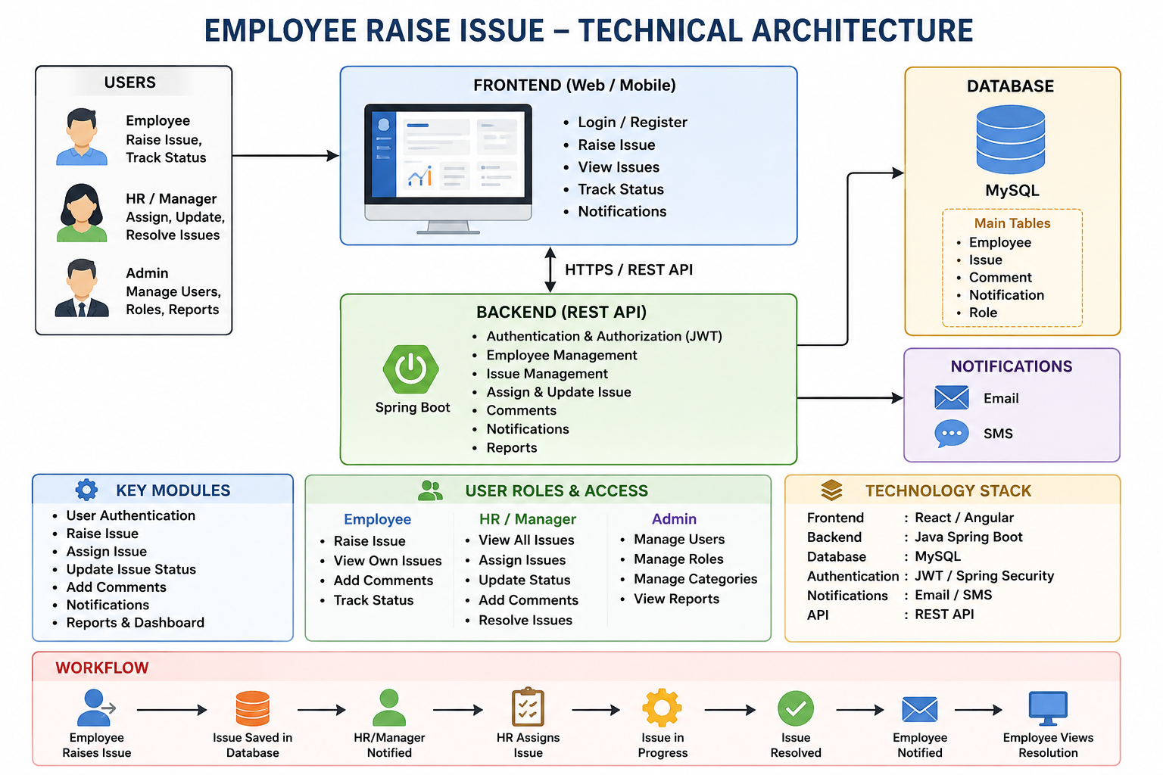

Table-1: Technical Architecture:
S.No | Characteristics | Description | Technology
1 | Application / Presentation Layer | Provides UI for employees, HR/Managers and Admin to login, raise issues, track issues and manage issues. | React.js / HTML, CSS, JavaScript
2 | Application Logic-1 | Handles employee registration, login, authentication, roles and user management. | Java / Spring Boot
3 | Application Logic-2 | Handles issue creation, assignment, priority, status updates, comments and issue resolution. | Java / Spring Boot REST API
4 | Application Logic-3 | Handles notifications to employees and HR/Managers when an issue is raised or updated. | Java / Spring Boot + Email API
5 | Database | Stores employee details, issue details, comments, issue status, priority and roles. | MySQL
6 | Cloud Database | Optional cloud-based database for deploying the application and storing data remotely. | MySQL Cloud / AWS RDS
7 | File Storage | Stores supporting documents or images attached to an issue, if required. | Local File System / AWS S3
8 | External API-1 | Email notification service used to notify HR/Managers and employees about issue updates. | SMTP / Email API
9 | External API-2 | Optional API for sending SMS notifications when an issue is raised or resolved. | Twilio / SMS API
10 | Machine Learning Model | Not required for the basic project. Can optionally classify issues automatically based on their description. | Not Applicable / Optional Python ML
11 | Infrastructure (Server / Cloud) | Hosts the frontend and backend application. The application can be deployed locally or on a cloud server. | Localhost / AWS / Docker

Table-2: Application Characteristics:
S.No | Characteristics | Description | Technology
1 | Open-Source Frameworks | Open-source frameworks are used to develop the user interface and backend services. They provide reusable components and make application development easier and faster. | React.js, Spring Boot, Spring Security
2 | Security Implementations | The application provides secure login, user authentication and role-based access. Employees can access their own issues, while HR/Managers can access and manage assigned issues. Passwords are stored in encrypted/hashed form and APIs are protected. | Spring Security, JWT, BCrypt, HTTPS, Role-Based Access Control (RBAC)
3 | Scalable Architecture | The application follows a 3-tier architecture consisting of Presentation Layer, Business Logic Layer and Database Layer. These layers are separated, making it easier to maintain the system and increase users or functionality in the future. | React.js, Spring Boot REST API, MySQL
4 | Availability | The application can be deployed on a cloud or local server. Database backup and proper server configuration can be used to reduce downtime and keep employee issue data available. | AWS / Docker, MySQL, Spring Boot

